**Pharmaceutical Database Project – Phase I**

**Business Overview:**

HAMY Biologics Pvt. Ltd. is a global biopharmaceutical company mainly focused on the haematology and gastroenterology therapeutic areas over the past 70 years. The goal of the company is to strengthen the global health systems to cater to physicians’ needs, improve people's health and have a safer future for them around the world by developing medicines and vaccines for patients.

**Problem:**

HAMY Biologics Pvt. Ltd. has recently discovered an upsurge in their sales due to their competitor product going off-patent. Hence, the company wants to know how well its products are doing in various parts of Europe. Moreover, there has been a recent hike in ad-hoc queries from the field representatives regarding the sales in their territories. Addressing individual queries has become time consuming and hence the company has decided to start creating and rolling weekly sales reports to the field to address both these problems. Providing periodic sales reports will reduce the number of ad-hoc queries from the field. In the reports, the company also wants to know how many interactions have occurred between the patient and the doctor regarding the company's product. The organization has also requested that access level reports be created such that employees have access only to their own regions in the report. Sales data is expected to be reported at location, HCP, HCO, and patient level. It would also be better to know how many new and current patients are being treated based on care with the company's product; and product sales against competitor sales to monitor the performance.

**Solution:**

Project team will create database to store and analyse the data received from the upstream and will create reports based on captured data according to the business requirements mentioned in the problem.

Final reports are expected to derive metrics at the below mentioned levels:

* Location
* Customer (HCP/HCO)
* Competitor and Market
* Patient

**Potential Benefits:**

The reports will help in deciding the future strategy of the company based on the reported information generated through the data. The reports will also help for financial planning, budget allocation and to take high business level decision with precise acumen. Also, it will help to increase sales based on the past data. Generating weekly reports will also reduce the resource efforts and time in addressing the adhoc queries which will eventually help to divert the focus on more important topics.

**Users of the database:** Backend software engineer, Data analyst, business analyst, Database management team, ETL developers and technical support team.

**Business Rules and Relationships**:

The data will be aggregated based on the below rules:

1. Company sales are recorded based on the products sold to customer for treating the patient. Customer can have many have many sales and sale will be recorded for each customer.
2. Customer belongs to only one country and a country can have multiple customers.
3. Reports be created such that pharmaceutical company employees only have access to the required regions/countries of the reports. An employee can have access to the reports of multiple countries and a country report can be assigned to multiple employees.
4. The number of interactions happened with the patients using company’s product should be captured to understand product’s demand and sales in particular area and which customer is likely prescribing the company’s product rather than competitor product. A product can be a part of one or many interactions while a unique interaction can happen for only one product.
5. The company needs to understand the new and existing patient count treated with company’s product and to determine how many of them have been switched to different product. A patient can be treated with multiple products and a product can be used to treat a multiple patient. Additionally, company wants to identify which customer has prescribed their product or competitor product for a particular patient.
6. No samples will be included in the HCP sales since they have no monetary gain for the company
7. Both retail, non-retail sales to be considered for HCOs
8. Patient which has been prescribed a drug will only be called a new patient only if he has not been prescribed the same drug in the past 52 weeks.

**ERD Diagram:**

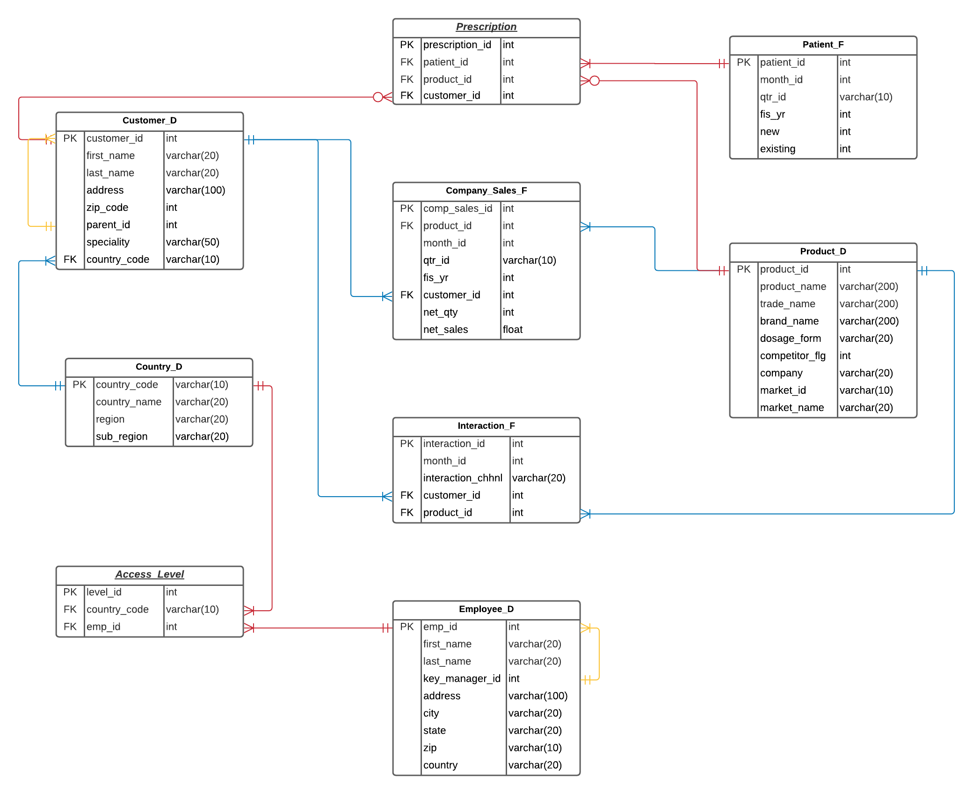

**Explanation:**

* **Customer_D:** It is a customer dimension table which will consist data of the healthcare professional (HCP), healthcare organisation (HCO) and pharmacies. Also, it will consist of the parent’s data of the HCP and pharmacies.

Eg: John Wilson (HCP) works at Apollo Hospital (HCO) -- Here child will be John and Apollo will be parent.

* **Product_D:** It is product dimension table which will consist data of company’s product and competitor product with their trade name and brand name and which market it belongs to.

E.g., Entyvio AL -500mg, Entyvio AL- 100mg (these 2 products will come under Entyvio Brand)

* **Company_sales_F:** It is a fact table which will consist of company’s sales data for the products month wise, quarter wise, year wise. Also, the data further will be divided into different countries and based on the sales happened for customers.
* **Patient_F:** It is a fact table which will consist of data like how many patients were treated month wise, quarter wise and year wise. Also, it will consist of data about how many new patients and existing patients are available.
* **Employee_D**: It is a dimension table which will consist of Employee information which can be used for giving access to specific reports.
* **Country_D**: It is a dimension table which will consist of the data which will have country code, sub_region and region information.
* **Interaction_F**: It is a fact table which will consist of number of interactions Customer interaction for the product information will be stored in this table along with the interaction channel.
* **Access_Level :**  It is an associative entity used to resolve the many to many relationships between the country_d and employee_d table.
* **Prescription:** It is an associative entity used to resolve the many to many relationship between the patient_f and product_d table.

**Data Dictionary: (refer to the attached excel)**



**Script File**

